Project Design Phase-II
Data Flow Diagram & User Stories

Date | 30 September 2026
Team ID | SWTID-2026-7361
Project Name | AI Blog Nest API
Maximum Marks | 4 Marks

Data Flow Diagrams:
A Data Flow Diagram (DFD) is a traditional visual representation of the information flows within a system. A neat and clear DFD can depict the right amount of the system requirement graphically. It shows how data enters and leaves the system, what changes the information, and where data is stored.
Example:
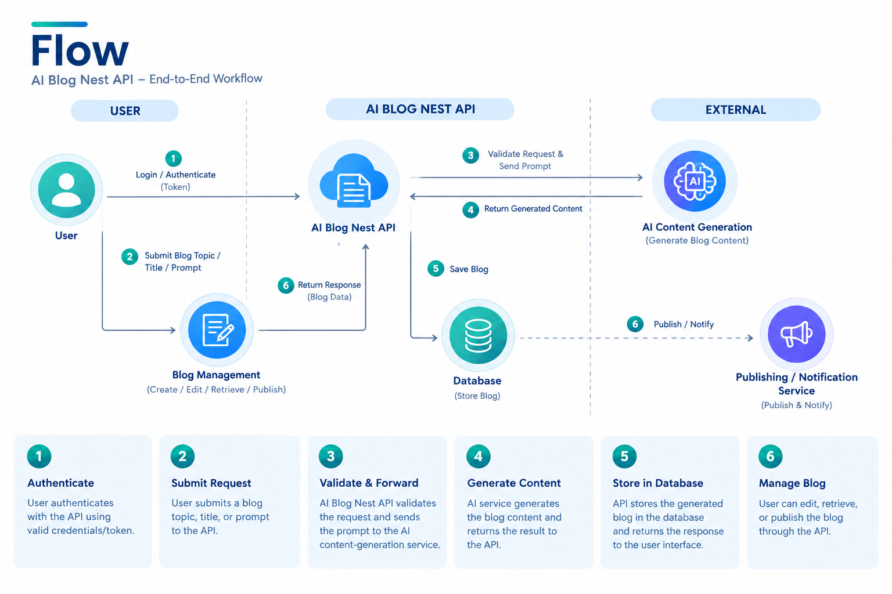

AI Blog Nest API – User Stories
Use the below template to list all the user stories for the product.
User Type | Functional Requirement (Epic) | User Story Number | User Story / Task | Acceptance criteria | Priority | Release
Customer/ Blogger | Registration | USN-1 | As a user, I can create an account using my name, email, and password. | Account is created successfully. | High | Sprint-1
Customer / Blogger | Login | USN-2 | As a user, I can log in using my email and password. | User can access the dashboard. | High | Sprint-1
Customer / Blogger | AI Blog Generation | USN-3 | As a user, I can generate a blog by entering a topic or prompt. | AI generates relevant blog content. | High | Sprint-1
Customer / Blogger | Blog Management | USN-4 |  | Blog changes are saved correctly. | High | Sprint-1
  As a user, I can create, edit, and delete my blogs.
Customer / Blogger | View Blogs | USN-5 | As a user, I can view my saved blogs. | All saved blogs are displayed. | Medium | Sprint-1
Customer / Blogger | Publish Blog | USN-6 | As a user, I can publish a completed blog. | Blog status changes to Published. | High | Sprint-2
Developer | API Integration | USN-7 | As a developer, I can use API endpoints to manage blogs. | API returns correct responses. | High | Sprint-2
Developer | Authentication | USN-8 |  | Unauthorized requests are rejected. | High | Sprint-2
  As a developer, I can securely authenticate API requests.
Administrator |  | USN-9 | As an administrator, I can manage registered users. | Admin can view and manage users. | Medium | Sprint-2
  User Management
Administrator | API Monitoring | USN-10 | As an administrator, I can monitor API errors and requests. | API activity and errors can be monitored. | Medium | Sprint-2

